**Creating Web Applications with PHP and MySQL in Ubuntu**

**Table of Content**

Install Apache: 2

Install mysql 3

Create the database in mysql 3

Create Website 3

Access Website: 6

**Web Development with Ubuntu Hosting: Creating Interactive Applications with PHP and MySQL**

Install Apache:

1. Open a terminal and run the following command to install Apache:

sudo apt update sudo apt install apache2

1. This will install the Apache web server on your Ubuntu machine.
2. After the installation is complete, start the Apache service with the following command:

sudo systemctl start apache2

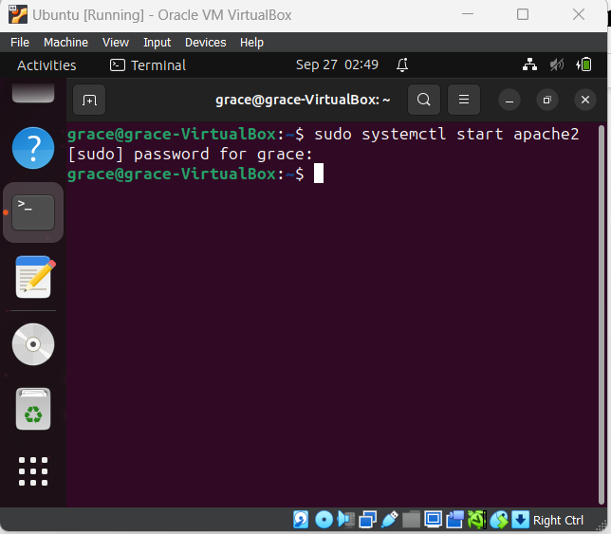

1. Open a web browser on the same machine or any other device on the same network and enter the IP address of your Ubuntu machine. You should see the default Apache landing page.

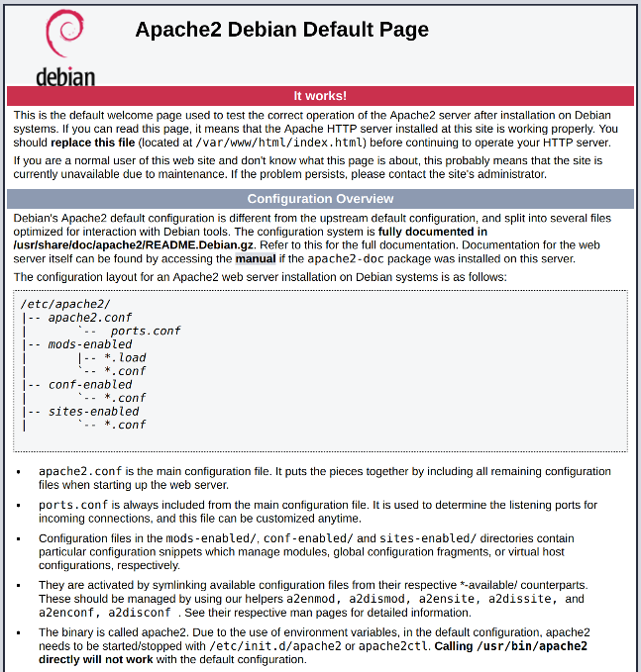

1. To find the IP address of your Ubuntu machine, you can use the command:

ip addr

# Install mysql

1. The install the mysql-server package:

sudo apt install mysql-server

1. Ensure that the server is running using the systemctl start command:

sudo systemctl start mysql.service

# Create the database in mysql

* Create database students;
* Use students;
* CREATE TABLE student_data (

student_id INT AUTO_INCREMENT PRIMARY KEY,

name VARCHAR(255),

username VARCHAR(255),

password VARCHAR(255),

programme VARCHAR(255),

birthdate DATE,

phone_number VARCHAR(10) UNIQUE

);

* CREATE TABLE fee_table (

fee_id INT AUTO_INCREMENT PRIMARY KEY,

student_id INT,

fee_amount DECIMAL(10, 2),

payment_date DATE,

FOREIGN KEY (student_id) REFERENCES student_data(student_id)

);

# Create Website

1. Create the Php and any other necessary files for your website (html, css). Place these files in the **/var/www/html** directory.
2. For example, create a file called **index.php**:

sudo nano /var/www/html/index.php

1. Add your php content and save the file.
   1. Config.php

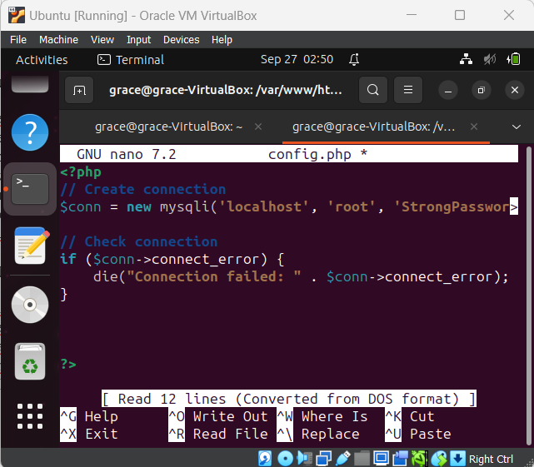

* 1. Index.php

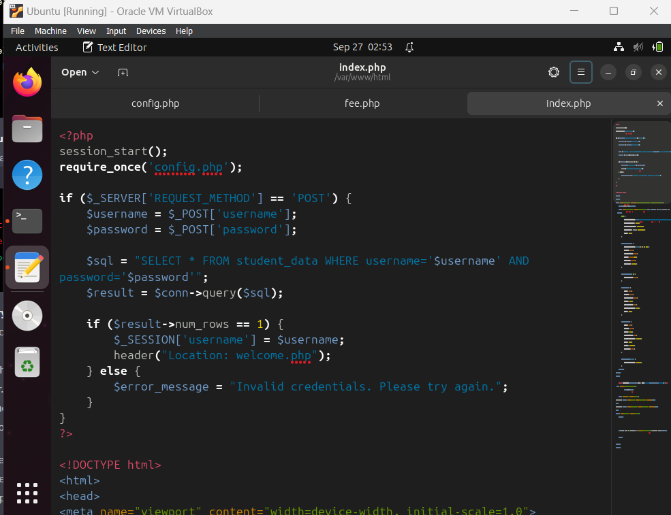 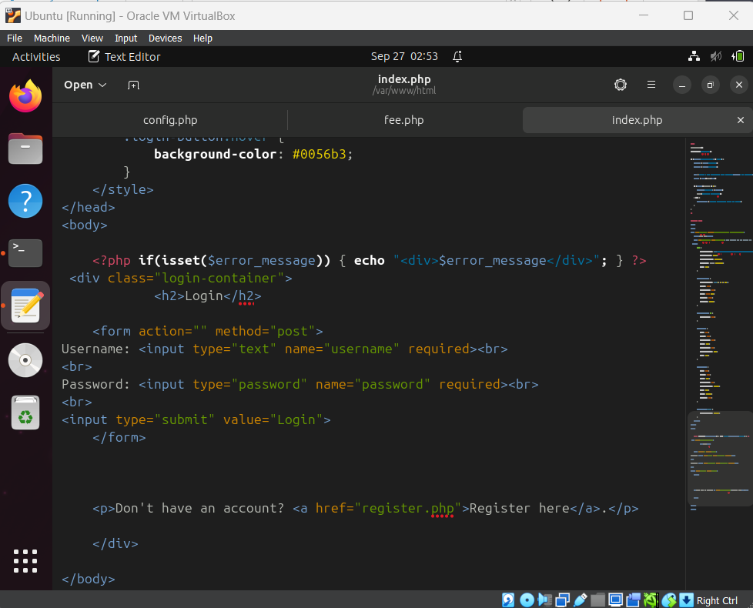

* 1. Register.php

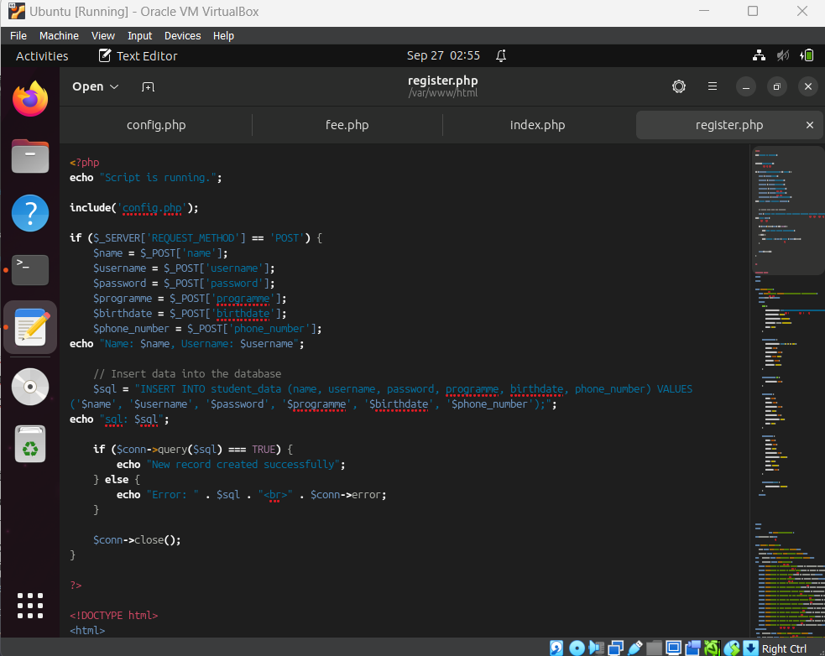 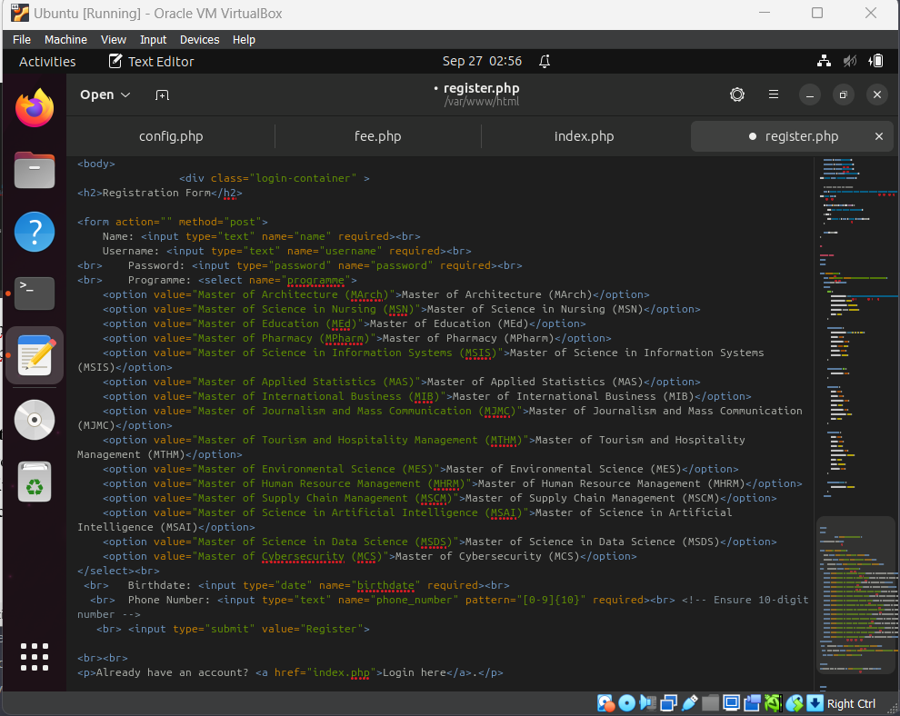

* 1. Welcome.php

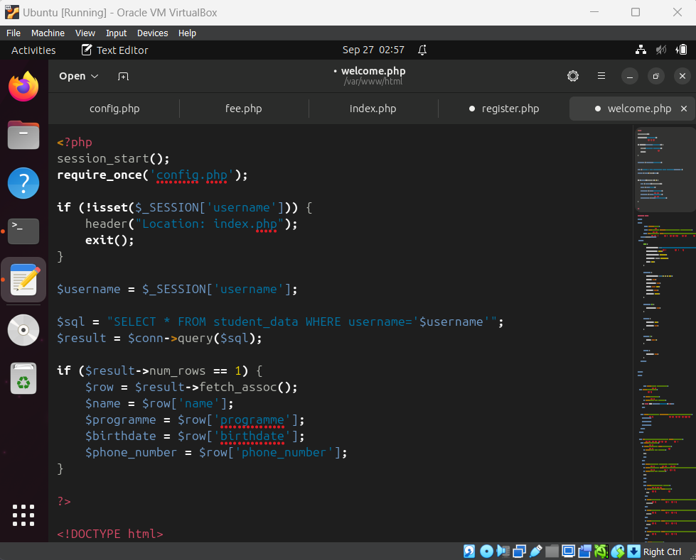 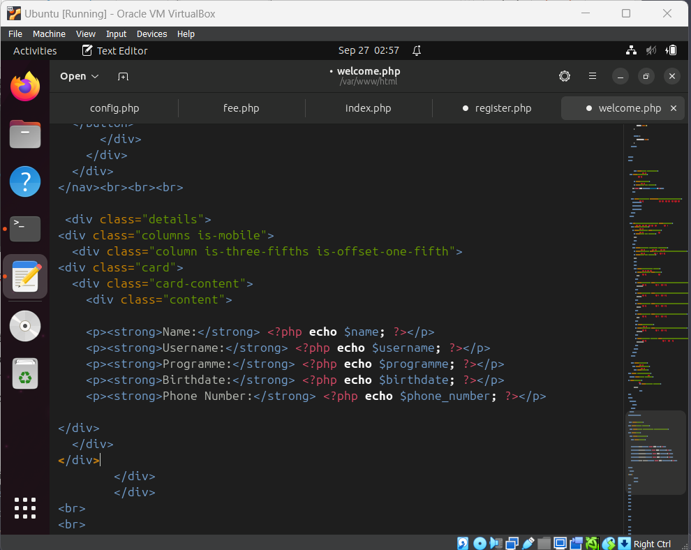

* 1. Fee.php

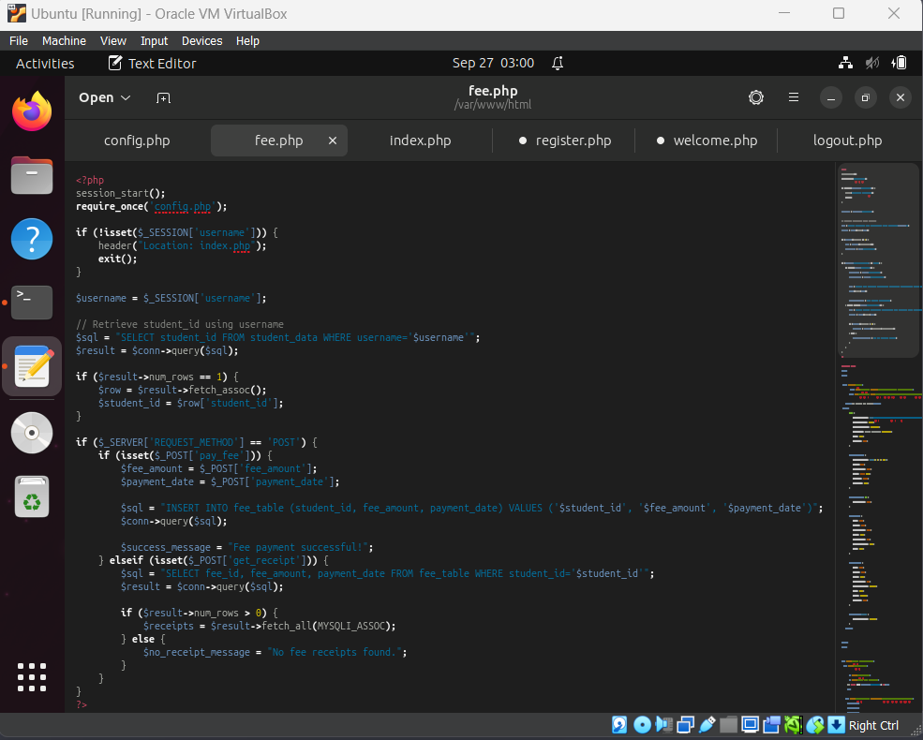 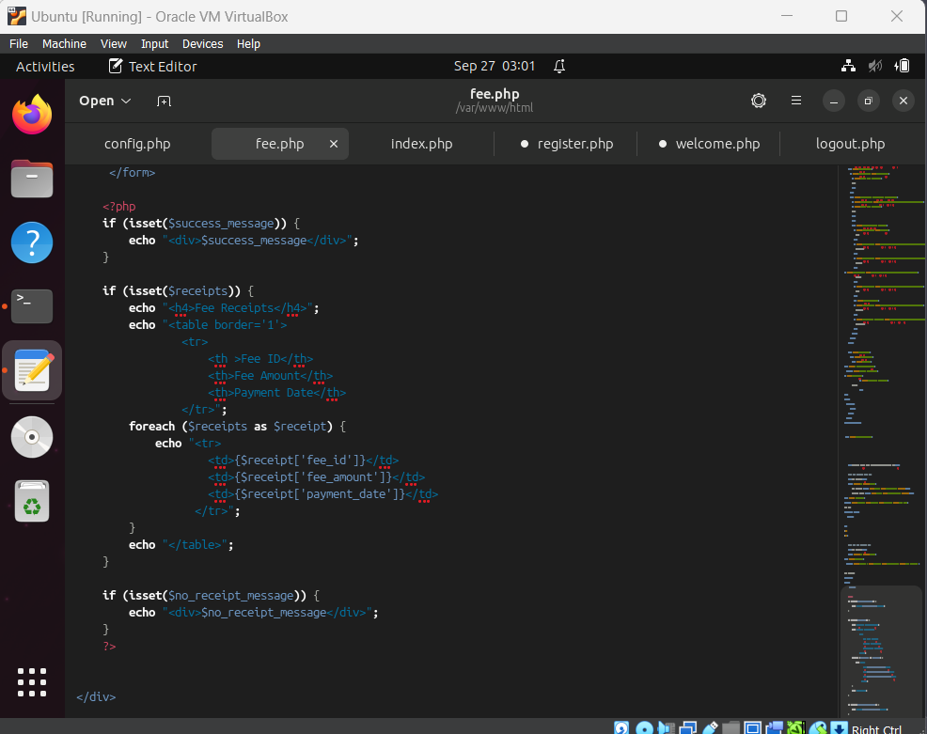

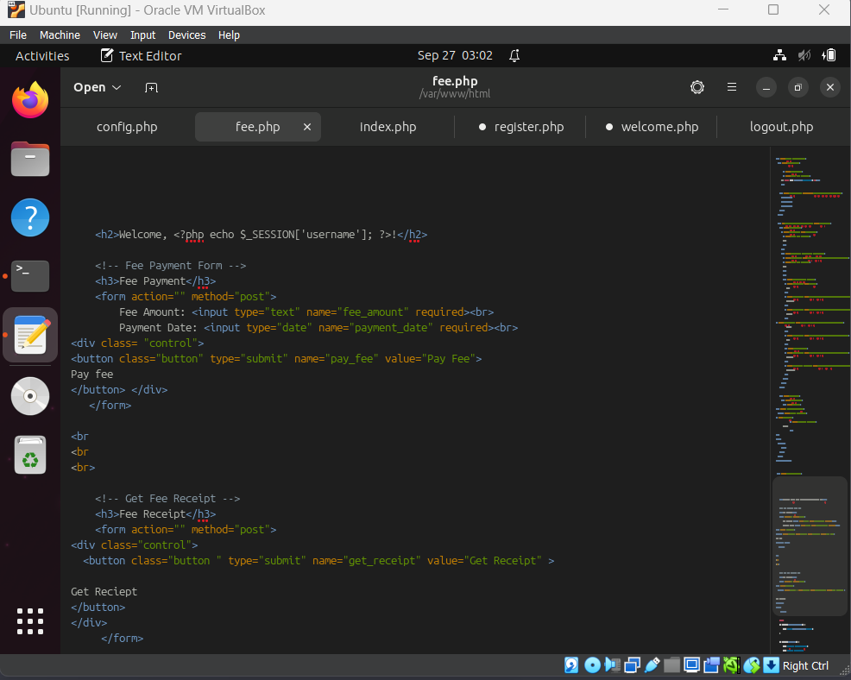

* 1. Logout.php

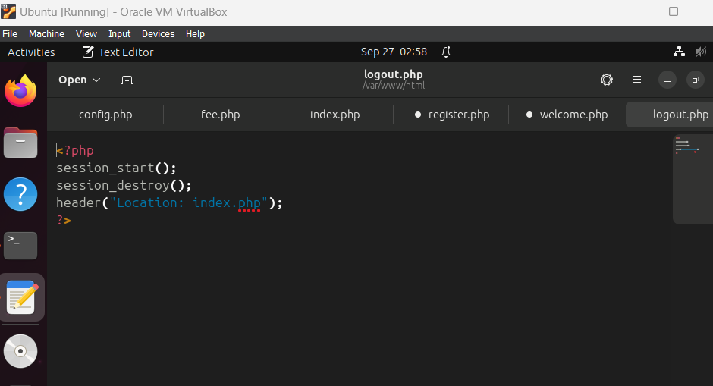

# Access Website:

1. Open a web browser and enter the IP address of your Ubuntu machine. You should see your website's content.
2. We need to access the website using the IP address.













